Project: Raspberry Pi Camera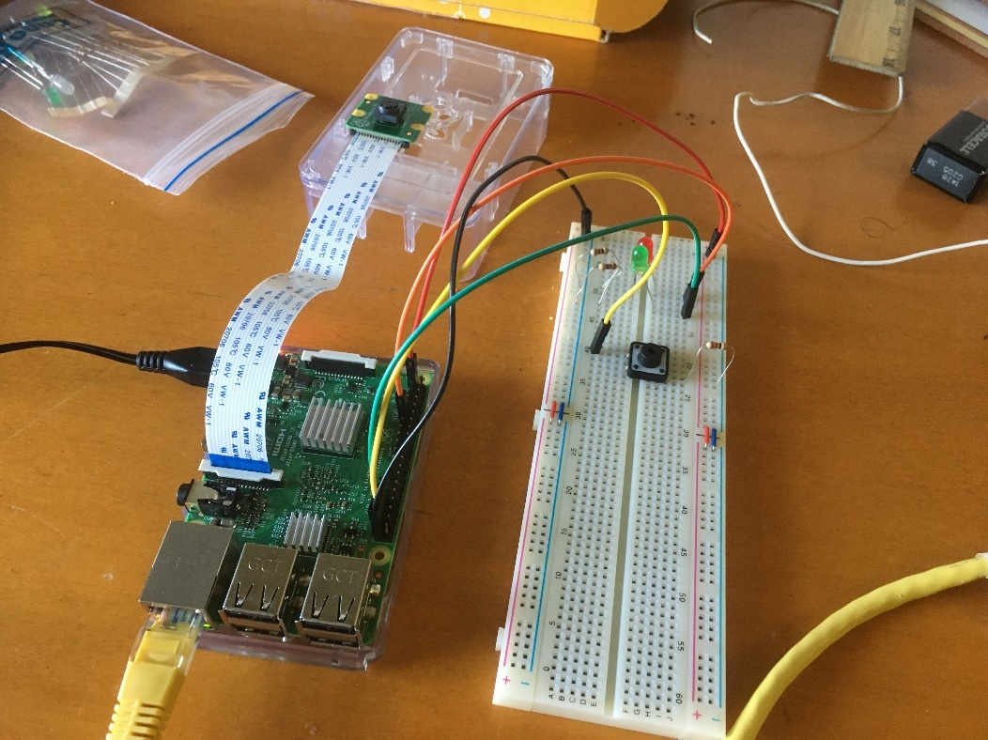

Materials:

* Raspberry pi
* Raspberry Camera Module
* Breadboard
* Male to Female connectors
* 2 LEDS (Red and Green)
* Push Button
* Ethernet Cable
* Putty and VNC (for remote hosting)

Summary: Using a program and pi’s GPIO ports, I made the pi into a simple camera that captures and saves images to jpg, png, jpeg, bmp, and all other image formats supported by the pi. Due to location and lack of access to a monitor and keyboard, I connected my pi to host laptop remotely via SSH using Putty and hosted the OS using VNC.

Setup: I connected all necessary GPIO pins to a breadboard as shown below. For the components, the red LED is connected to pin 17, green LED to pin 13, and the button to pin 26; each component is connected to a resistor. As for powering the circuit, I used 3.3V (connected to pin 1) and used pin 39 as the grounding.

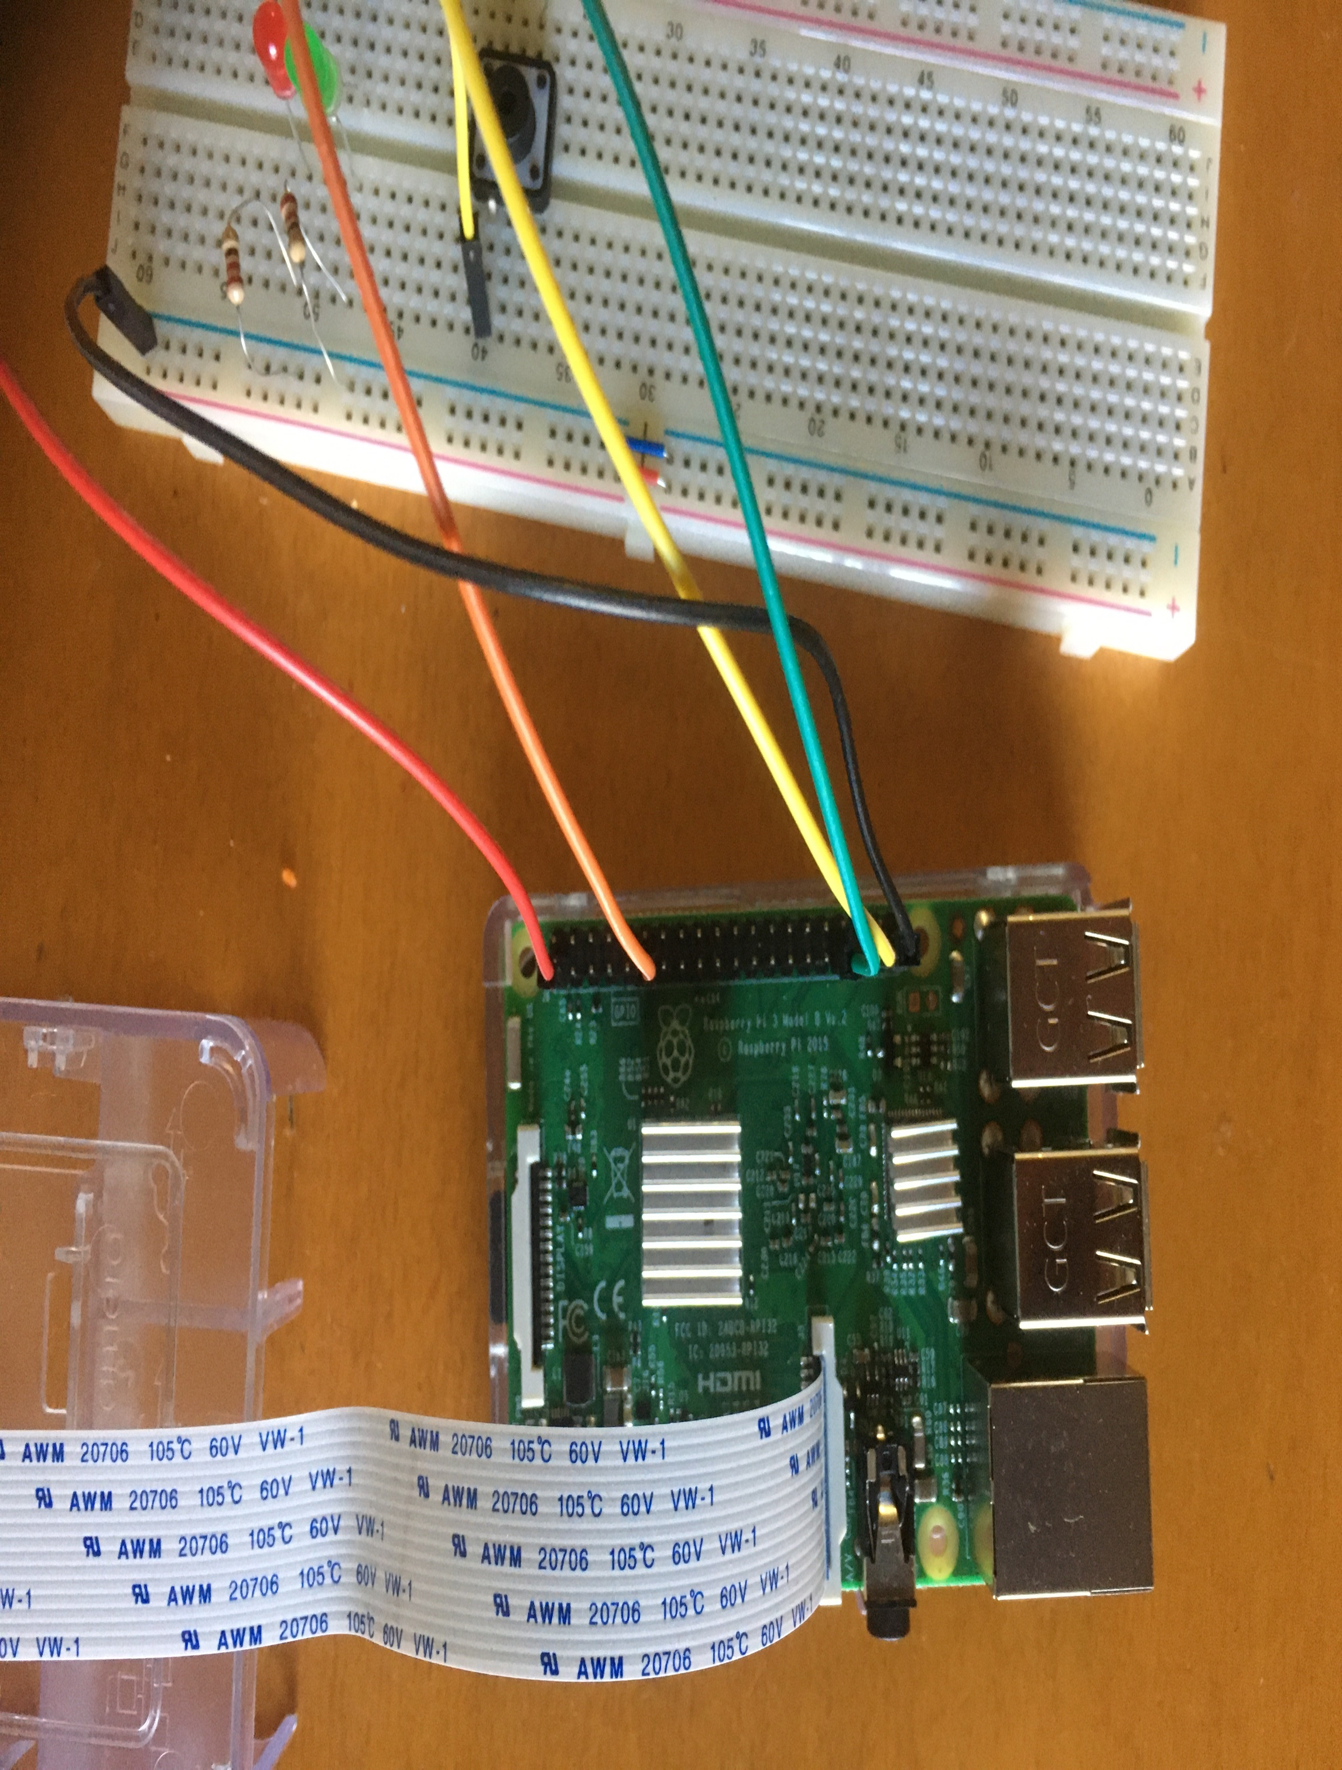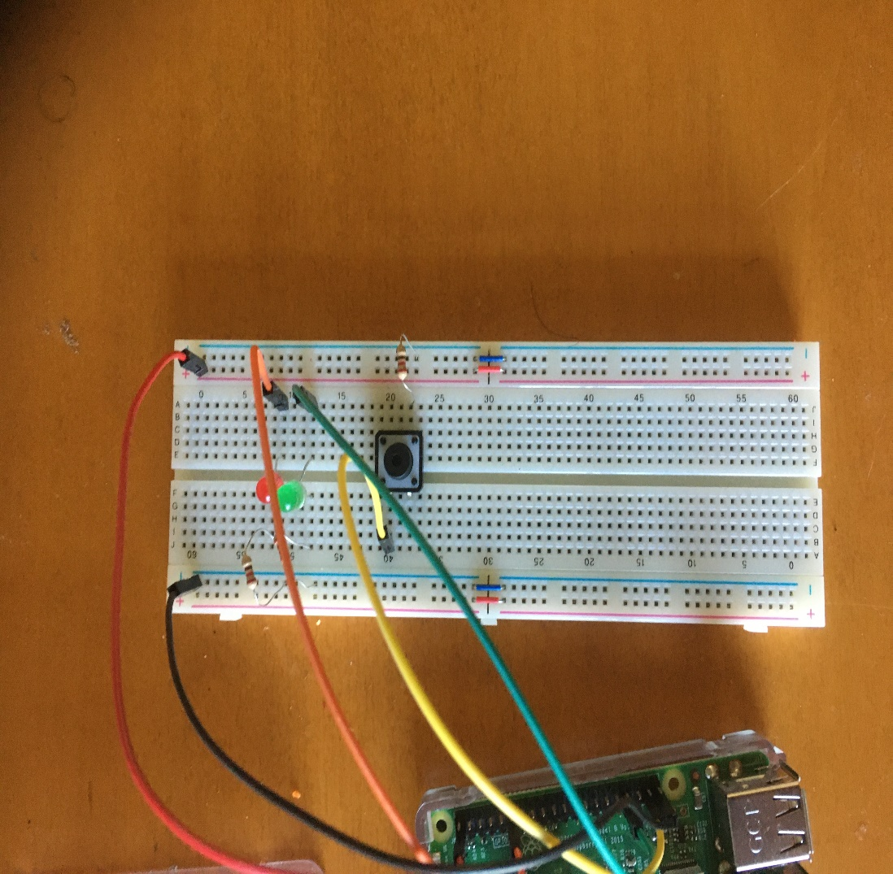

\* Important Notes:

- The red LED is used to verify that the camera preview is initiated by the code, and the green LED is used to verify that the image was saved.

-I have only tested this code within the Pi’s OS (Raspian) as of May 2, 2020.

Results:



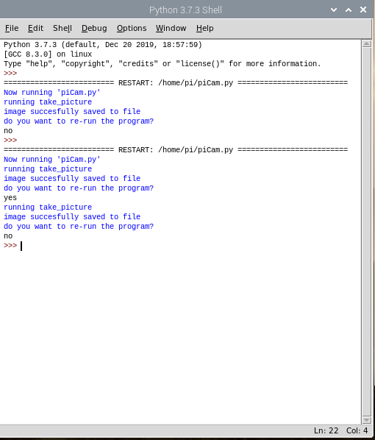

Output from running the code